Right Time to Archery Elk Hunt
by Steve Ficco

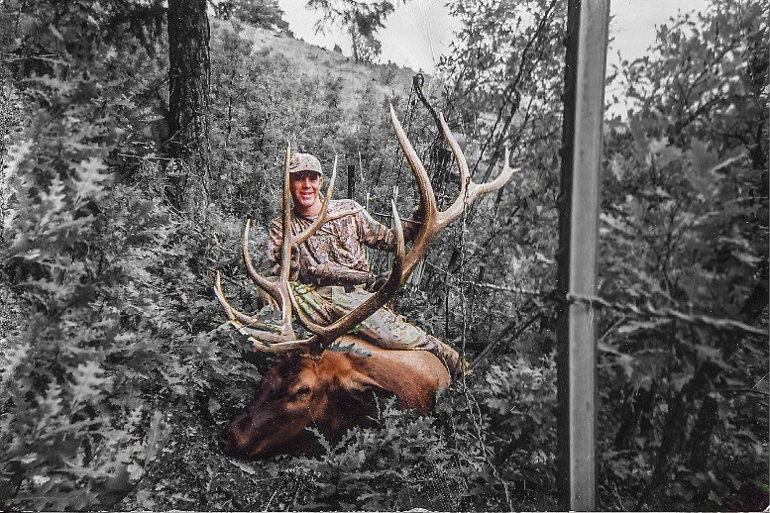
Every year I get the same phone calls, the same emails, all for the same question...If you were going archery elk hunting in Colorado, and only had five days to hunt, when would you go? I reply, what kind of elk hunting experience do you want to have? I would then get a look of confusion.
I have been hunting elk with my father and mentor Ron Ficco since I was twelve years old. At twelve I was not old enough to carry a gun or bow, but still my training began as I went along and learned the basics of elk hunting. At that young age I learned the importance of how to read thermals and wind direction. I was taught how to find my patience, when to move, when to sit, and when calls work and don't work. Primarily in those earlier years we rifle hunted. We own horses and have done full pack trips while rifle hunting and bow hunting; packed in with back packs, and hunted on foot out of base camps; all of which occurred on public land do it yourself hunts.
When I was eighteen I became interested in archery hunting. This came after watching Larry Jones, Dwight Schuh, and Pete Shepley elk hunting with a bow. I bought my first compound bow and I was hooked. The first years of hunting I would head to the hills on opening day for a three or four day hunt. More often than not I would see more big bulls but have a lot of trouble getting close enough to do anything. I would come back home, take a short break and then return back to the hills. It seemed that as the season rolled on I would see more elk and definitely hear more bulls bugling. If I was not having the success that every hunter hopes for, I would continue going back up in the high country again and again until the season had closed.
In my nineteen years of archery elk hunting I have come to a couple conclusions. First, in my opinion and experience, I have seen more big mature bulls early in the season with fewer cows then later. These big bulls are less likely to come into calls but more often than not they are much easier to stalk into that magical sixty to eighty yard range. These big bulls do not seem to make a lot of noise (bugling) and are often with only one or two other bulls at that time.
On the other hand; as the archery season rolls on, big bulls get their harems together, their testosterone increases, and the bulls become more vocal. The big herds seem to have several other satellite bulls mixed in or around the outskirts of the herd and this is when bulls seem to be more susceptible to come in to investigate your soft sweet cow calls or high pitched bugles.
So back to the original question; when would I go archery elk hunting? Earlier is better for getting a chance for a big mature bull but with that comes a lower success rate due to them being relatively hard to locate and not interested in cows making them less receptive to calls. Later is better for more opportunity with several other bulls around, and they are easier to locate due to the increase in bugling as the rut begins to peak. In the end it comes down to what each particular hunter wants to achieve. Chase a giant herd bull early in the season which many times the action can be slow and the woods may be quiet; or hunt during the peak of the rut, when bulls from every direction seem to be bugling and wanting to partake in the mating ritual. At this time however, the giant herd bull has surrounded himself with a lot more eyes and noses to sense danger, making him a much more difficult target than he was a few weeks earlier. To optimize your success, hunt as often as you can in the season, early and late. Make the best of your time and enjoy it. Any elk with a bow; whether bull or cow; is a success. Good luck and hunt hard!

